- The media debate around whether the Chancellor exaggerated the size of the UK's fiscal repair job is misplaced, in our view. The bigger issue is that the deficit reduction plan is based on the unlikely prospect of a significant tightening in an election year and optimistic GDP forecasts. Markets have given the government the benefit of the doubt so far, but that might not last.
- Market pricing implies a December rate cut is almost certain, but we think the decision will be a closer call. The vote will likely be 5-4, with Governor Andrew Bailey casting the decisive vote. This week's Bank of England Decision Maker Panel suggested inflation and pay growth remain sticky, and the evidence to suggest Bailey will switch to vote to cut remains inconclusive.
More than a week on, the Budget continues to dominate the domestic media coverage. In part this reflects the fallout from the leaked Office for Budget Responsibility forecast, which resulted in the OBR's chair, Richard Hughes, stepping down this week. But most of the coverage has focused on the question of whether Chancellor Rachel Reeves had misled the country about the size of the fiscal repair job.
The debate centred on the idea that the OBR's pre-measures forecast showed the current budget in surplus in fiscal year 2029-2030, thus complying with the fiscal rules. But that surplus was just £4.2bn, less than half the already-slim headroom left in the two previous fiscal events. And that forecast didn't include the summer U-turn on welfare spending, which more than wiped out that headroom. So it's hard to square the notion that the Chancellor exaggerated the fiscal problems and tightened policy by more than necessary.
From our perspective, the main issue remains the lack of credibility around the tightening plans. As was the case when the previous Conservative government said it would cut borrowing via implausible-looking back-loaded spending cuts, markets appear to have taken the government at face value when it says it will tighten policy significantly – mainly via large tax rises – in election year. But we're sceptical this optimistic take will hold. There are also major question marks over whether the tax hikes will generate the anticipated uplift in revenue and the Office for Budget Responsibility's GDP forecasts look optimistic. As we argued in our preview of the key themes that will shape the economy in 2026, fiscal risks will remain elevated.
Chart 1: Markets see a December rate cut as a done deal; we think it will be a much closer call
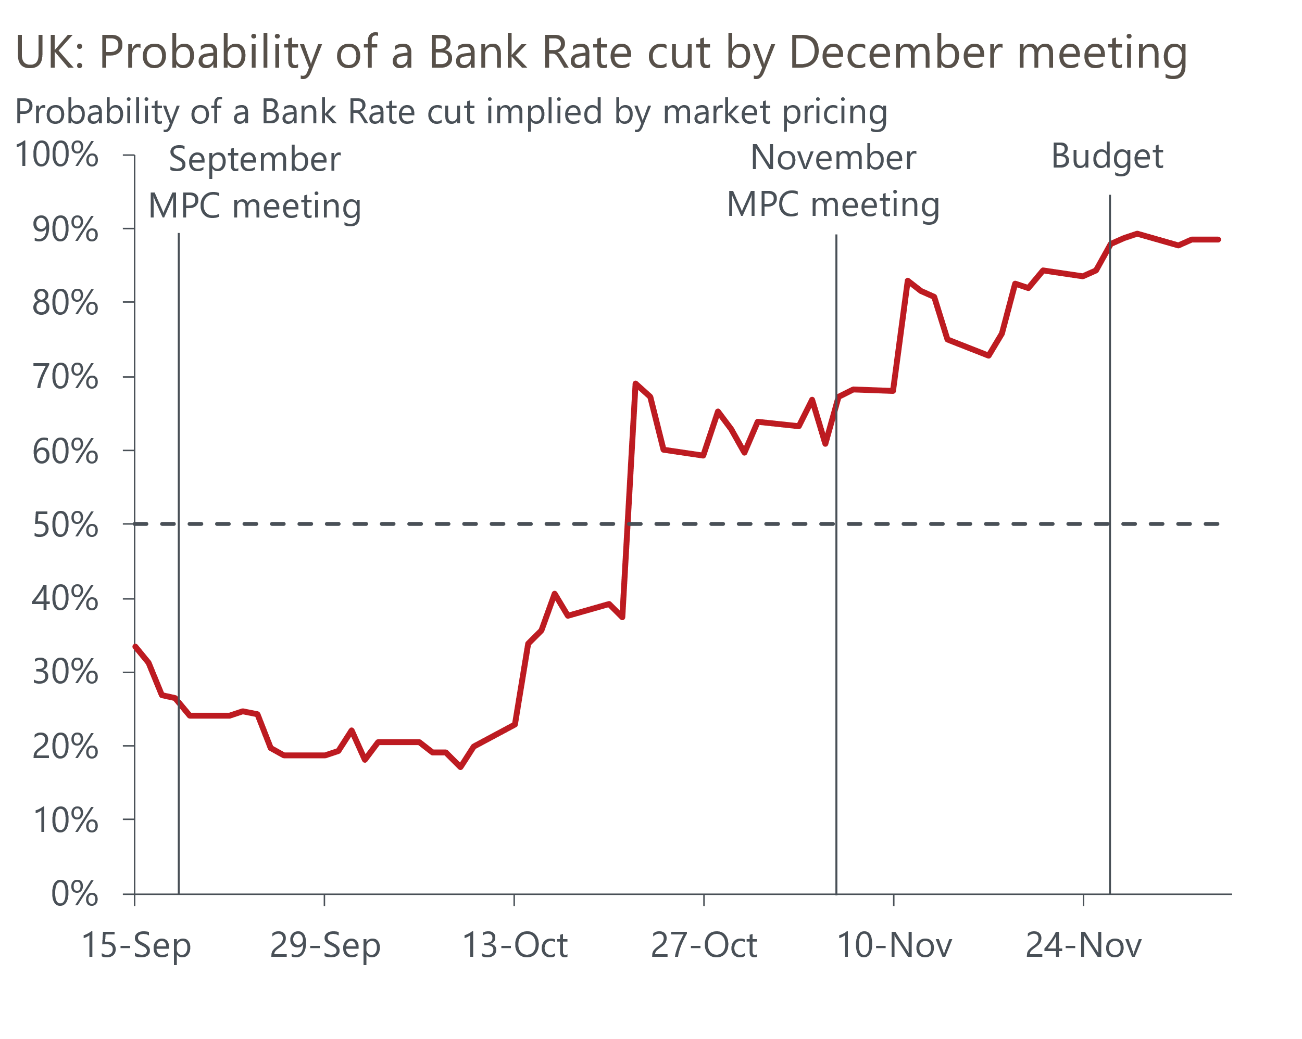
Source: Oxford Economics calculations using data from Haver Analytics

Despite a modest near-term loosening of fiscal policy, markets don’t think the Budget changed the likely outcome of December's Monetary Policy Committee meeting. Current pricing suggests an 88% chance of a rate cut on December 18, but we think the decision is likely to be a much closer call (Chart 1).
For starters, based on the individual statements made in the minutes of last month's meeting, we have a pretty good idea that four members will vote to hold and four will vote to cut. So, as has been the case in two of the past three meetings, the decision will come down to which group Governor Andrew Bailey sides with. Bailey's statement indicated a bias to cut at one of the upcoming meetings, but neither the Budget nor recent data have offered decisive reasons to switch sides so far.
This week's data added to the fog. The Bank of England's Decision Maker Panel, which has been a key influence on the committee's thinking in recent years, suggested that the downward momentum behind inflation and pay growth has petered out (Chart 2). Most notably, firms' expectations for pay growth over the coming year nudged up in November and are running at a level much higher than would be consistent with the BoE achieving its inflation target over the medium-term.
Chart 2: The BoE DMP suggests wage growth and price inflation remain sticky
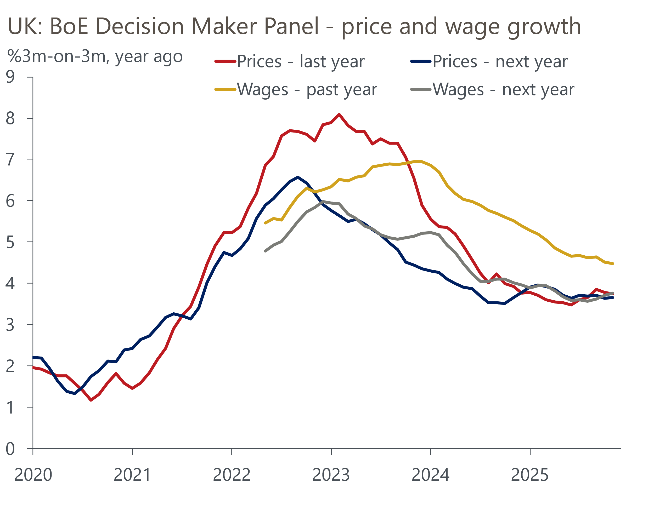
Source: Bank of England Decision Maker Panel
Set against the story of sticky wage growth and price inflation, the DMP reported the steepest fall in employment on a three-months-on-three-months basis since the latter stages of the pandemic. Given the responses to this question can be very volatile, and the three-month average was dragged down by an exceptionally weak reading for November, some caution must be exercised in interpreting this data. But it does chime with the recent softening in HMRC's count of payrolled employees, so is likely to concern those MPC members worried that weak demand could trigger a more abrupt drop in inflation over the next couple of years.
November's S&P Global surveys told a more encouraging story on costs and prices, with the services survey reporting the weakest balance for inflation for nearly five years. But the MPC is likely to place a higher weight on the results of the BoE's own survey, particularly given the S&P Global surveys have become much less reliable leading indicators of official data in recent years.
That's also likely to be the case for activity, where November's final composite PMI showed a chunky upward revision to the flash result, although that still left the balance well down on October's outturn. Volatile results and large revisions between the flash and final surveys mean we place very little store on the signals coming from these surveys.
On balance, we continue to think that the MPC will cut at one of the next two meetings and favour the December meeting. But we are much less confident in that outcome than markets appear to be. Indeed, it could be that the November inflation data, due to be published the day before the MPC's announcement, proves to be the decisive factor.

The week ahead
Next week's only major release is the GDP data for October. Output fell 0.1% m/m in September due to a slump in industrial production. In large part this was due to a major motor manufacturer halting production due to a cyber-attack. Given that production resumed gradually from mid-October, there's likely to have been a partial rebound in manufacturing output that month. We expect services output to be broadly flat on the month, which should leave GDP up 0.1% m/m in October.
Table 1: Week ahead calendar
Date | Events | Period | Measure | Unit | Previous | Forecast
Dec 12 | GDP | Oct | m/m | % | -0.1 | 0.1
Dec 12 | GDP | Oct | 3m/3m | % | 0.3 | 0.0
Dec 12 | Index of services | Oct | m/m | % | 0.2 | 0.0
Dec 12 | Index of services | Oct | 3m/3m | % | 0.2 | 0.1
Dec 12 | Manufacturing output | Oct | m/m | % | -1.7 | 0.7
Dec 12 | Manufacturing output | Oct | y/y | % | -2.2 | -0.6
Dec 12 | Industrial production | Oct | m/m | % | -2.0 | 1.0
Dec 12 | Industrial production | Oct | y/y | % | -2.5 | -0.9
Dec 12 | Construction output | Oct | m/m | % | 0.2 | 0.0
Dec 12 | Construction output | Oct | y/y | % | 1.3 | 1.6
Dec 12 | UK trade | Oct | Trade balance | £bn | -1.1 | -1.2
Dec 12 | UK trade | Oct | Visible balance | £bn | -18.9 | -19.1
Source: Oxford Economics

Key forecasts
Table 2: UK forecast overview
(Annual percentage changes unless specified)
 | 2023 | 2024 | 2025 | 2026 | 2027 | 2028
GDP | 0.3 | 1.1 | 1.4 | 1.0 | 1.4 | 1.5
Private consumption | -0.3 | -0.2 | 0.9 | 1.0 | 1.1 | 1.4
Fixed investment | 0.5 | 1.8 | 3.0 | 0.9 | 2.1 | 2.1
Government consumption | 2.1 | 3.4 | 2.0 | 2.0 | 1.7 | 1.4
Exports of goods and services | -2.3 | 0.6 | 2.8 | -0.4 | 1.0 | 1.3
Imports of goods and services | -1.6 | 2.6 | 3.6 | -0.4 | 1.2 | 1.4
Industrial production | -2.6 | -1.6 | -0.5 | -0.1 | 1.1 | 1.3
Consumer prices | 7.3 | 2.5 | 3.4 | 2.7 | 2.5 | 2.2
Unemployment rate (%) | 4.1 | 4.3 | 4.8 | 5.0 | 4.8 | 4.5
Current a/c balance (% of GDP) | -3.6 | -2.2 | -3.0 | -2.7 | -2.6 | -2.5
Government balance (% of GDP) | 5.2 | 5.2 | 5.0 | 3.9 | 3.3 | 2.8
Central bank policy rate (%, EOP) | 5.25 | 4.75 | 3.75 | 3.25 | 3.00 | 2.75
10yr govt. bond yield (%, EOP) | 3.54 | 4.57 | 4.60 | 4.39 | 3.89 | 3.65
Exchange rate (US$ per £, EOP) | 1.27 | 1.25 | 1.32 | 1.29 | 1.29 | 1.29
Exchange rate (euro per £, EOP) | 1.15 | 1.21 | 1.14 | 1.11 | 1.11 | 1.11
Source: Oxford Economics
Table 3: Quarterly forecasts for the UK
 | 2025 |  |  |  | 2026
 | Q1 | Q2 | Q3 | Q4 | Q1 | Q2 | Q3 | Q4
GDP (% year) | 1.8 | 1.4 | 1.3 | 1.2 | 0.8 | 0.8 | 1.0 | 1.2
CPI inflation (% year) | 2.8 | 3.5 | 3.8 | 3.6 | 3.4 | 2.4 | 2.5 | 2.5
Bank Rate (%, EOP) | 4.50 | 4.25 | 4.00 | 3.75 | 3.75 | 3.50 | 3.50 | 3.25
10yr gilt yield (%, EOP) | 4.70 | 4.48 | 4.70 | 4.60 | 4.60 | 4.57 | 4.49 | 4.39
US$ per £ (EOP) | 1.29 | 1.37 | 1.35 | 1.32 | 1.30 | 1.29 | 1.29 | 1.29
Euro per £ (EOP) | 1.20 | 1.17 | 1.15 | 1.14 | 1.12 | 1.11 | 1.11 | 1.11
Source: Oxford Economics

Latest Country Economic Forecast:
November 18, 2025

Recent publications

Data Insights
PMI points to an economy that is muddling along
Mortgage market firms up after Stamp Duty change
Pre-Budget concerns weigh on the PMI
October's drop in retail sales shouldn't be a source of concern
Precarious public finances make for a difficult Budget

Research Briefings
Key themes 2026 – Sluggish growth and fiscal worries
Budget papers over the cracks but can't hide the fiscal risks
Better affordability puts housing market on firmer footing
Dovish hold in November puts a December rate cut in play
MPC preview – softer data unlikely to herald November cut

Contacts

Oxford Economics' UK team
- Andrew Goodwin - Chief UK Economist - agoodwin@oxfordeconomics.com
- Edward Allenby - Senior UK Economist - eallenby@oxfordeconomics.com

